***Dior Rouge***

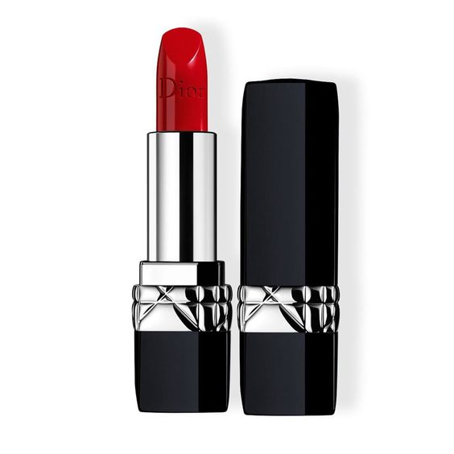

*Includes 6 lipstick colors of the limited edition of Dior's collection in celebration of this year's Christmas season. And all these 6 colors when you first look at it, make you fall in love immediately. Not only because all the colors are so beautiful, too flattering, but these are also Dior's best-selling colors. The perfect color mixing and calibration will leave you satisfied.*